

National Institute Of Technology Durgapur

Project Report

“Deals And Offers”

Master Of Computer Applications
Batch(2014-2017)

Under the esteemed guidance of Ms. Shailesh Pawar , Project Mentor with Ypsilon IT Solutions Ptd Ltd,
Indore.

Submitted By:

Tejshree Bakore(14/CA/619)

National Institute Of Technology
Mahatma Gandhi Avenue, Durgapur
India ,713209

__________________________________________________________________________________________

CERTIFICATE OF RECOMMENDATION

This Is to certify that the work contained in this project entitled, “Deals and Offers” , has been carried out by TEJSHREE BAKORE under my supervision and may be accepted in partial fulfilment of the undersigned and this work has not been submitted elsewhere for any other degree .

Dr. Anirban Sarkar Dr.Suvamoy Changder

Head Of Department Computer Applications
National Institute Of Technology Durgapur

National Institute Of Technology
Mahatma Gandhi Avenue, Durgapur
India ,713209

CERTIFICATE OF APPROVAL

The forgoing project is hereby approved as a creditable study of engeenering subject carried out and presented in a manner satisfactory to warrant its acceptance as a pre-requisite to obtain the degree for which it has been submitted . It is understood that by this approval the undersignes don’t necessarily endorse or approve any statement made , opinion or conclusion drawn there in but approve the thesis only for the purpose for which it has been submitted .

Board Of Examiners

2.

ABSTRACT

Phoenix is a leading multinational medical instruments and consumer care producing company . With the increasing number of Clients and supplier they aim to monitor their sales , marketing finance and budgeting decision .

The Project objective is to build a Datawarehouse using Microsoft SQL Server 2008 and Informatica 9.5.1 and a Dashboard using IBM Cognos 10.1 to assist Phoneix in order to control their sales, Marketing , Financial and Budgeting decisions. The Various Data provided by Phoneix is in Flat files .

The initial stage of project consists mainly of Data cleansing and Data Integration , This is done by scrubbing the data impurities and consolidating the data in a conformed format before loading it into the warehouse .
While doing so the various dimension of Data Quality is maintained viz. a viz. Accuracy, Consistency, Conformity,Completeness and Integrity.
The above is achieved using ETL tools provided by Informatica 9.5.1. The next Phase of the project mainly includes creating reports and dashboards using the cleansed data contained in the crteated Warehouse .

Keywords:-IBM Cognos 10.1, Informatica 9.5.1, ETL Tools , Data Cleansing, Data Integration

OBJECTIVE

- To create a Datawarehouse to manage the data in an effeciant and organised way .
- To Extract data from multiple sources (flat files /db files ) .
- Complete the required business requirement according to the need of client in Designer and in order to meet the requirement use the proper Transformation .
- After The completion of Transformation in mapping , session should be created so that we can run the workflow in workflow manager .
- Once after running the workflow we can see the validity of workflow in workflowMonitor part of Informatica.
- Finally the completed table should be displayed in MSSQOL SERVER 2008 and we can check weather the requirement met .
- Now using framework manager we have to Publish Package and work with this package in ReportStudio in IBM cognos to create a Dashboard .

ATTESTATION

We understand the nature of plagiarism and are aware of the University’s Policy. We certify
that this dissertation reports original work done by us during our paid Internship in Ypsilon IT Solutions Ptd. Ltd. Indore.

_____________________ __________________

Signature : Date :

ACKNOWLEDGEMENTS

Our sincere Thanks for the Kind support and help extended by many individuals in the esteemed organisation.

We are higly indebted to Mr. Shailesh Pawr and Mr. Anurag Saini who helped us by sharing their knowledge and deeper understanding about the website and various methodologies being followed at Ypsilon IT Solutions Pvt. Ltd. We are obliged for your untiring attention in answering our endless questions. This will facilitate in shaping our career in the right direction in fruitful manner .

TABLE OF CONTENTS

1. BUSINESS OF THE CUSTOMER 5
2. FUNCTIONAL REQUIREMENTS 5
2.1 REQUIREMENTS IN SCOPE 5
2.2 REQUIREMENTS OUT OF SCOPE 5
2.3 USER INTERFACE 5

3. NON FUNCTIONAL REQUIREMENTS 6
3.1 Security 6
3.2 Audit Trail 6
3.3 Error logging 6
3.4 Multi language Support 6
3.5 Performance 6
3.6 Scalability 6
3.7 Availability / reliability 6
3.8 Data migration 6
3.9 Data Retention 6
3.10 Legal/ regulatory requirements 6
4. LITERATURE REVIEW ……………………………………………………………………………………….
4.1 Microsoft SQL Studio 2010
4.2 ETL-Informatica
4.3 IBM Cognos

5. MATERIALS AND METHODOLOGIES :…………………………………………………………………
5.1 First Second And Third Stage
5.2 Description Of E-R Diagram
6. HARDWARE AND SOFTWARE REQUIREMENTS 6
6.1 Deployment Environment Requirements 6
6.2 Development Environment Requirements 6
7. REFERENCES 6
8. APPENDIX 6

BUSINESS OF THE CUSTOMER
Phoenix is a leading multinational medical instruments and consumer care producing company . With the increasing number of Clients and supplier they aim to monitor their sales , marketing finance and budgeting decision .

Phoenix Medical Systems
Phoenix Medical Systems was created in 1989 with the goal of providing cost-effective and innovative solutions for the care of neonates. Phoenix is pioneer in India in the manufacture of products devoted to infant health care, the first product being an infant incubator. The mission of Phoenix continues to be to provide solutions that match the best in the world at very affordable prices.

Products
The product range of Phoenix has expanded to include continuous positive airway pressure (CPAP) units, phototherapy units, electronic weighing scales, oxygen and apnea monitors and infant bassinets. The most versatile products in the Phoenix range include a comprehensive infant care centre, neonatal radiant warmer, neonatal phototherapy unit and obstetrics-gynaecology delivery table.
The comprehensive infant care centre is a single machine that combines several functions – it includes a radiant warmer, a resuscitation module, an innovative oval-shaped bed designed for convenient access, an easy-to-operate front panel, a graphic display, a pulse oximeter and a weighing machine.

The venture depends on Phoenix information stockroom which is a therapeutic manufacturing, Production and medication supplier to the significant doctors facilities and pharmacetucial Organisation .
Phoenix data has been only devoted to the social insurance industry . hundred percent of the business is social insurance related and our single claim to fame is gear upkeep administration programming.
Phoneix Data is known for our industry learning , unrivalled client administration and backing, sparing arrangement, fast quantifiable profit and high client consistency standard.

2 . E-R Diagram And Database Diagram

2.1 E-R Diagram :
The E-R Diagram displayed below contains 13 tables.
Customer,Supplier,Stock,Product,Employee,SupplyType,Location ,Component, component stock,ProductStock .
An appropriate relationship between the tables are also indicated using has –a and is-a Relationship.

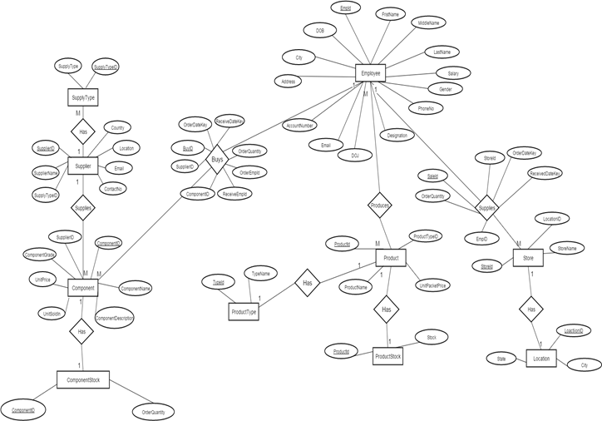

E-R Diagram

2.2 Database Diagram:

The database contains 13 tables corresponding to the tables- Employee, Supplier, Supplier Type, Component, Component Stock, Product, Product Type, Product Stock, Store and Location. Suppliers are specialized based on their type into 2 categories- Spare Parts and Drug Items. Product table consists of product details which is linked to Product Stock and Product Type. Component contains details of the various components that are supplied by the suppliers to the company. Employee table holds all the details of the employees working for the company. Store contains record for the different stores that the company supplies the products for.

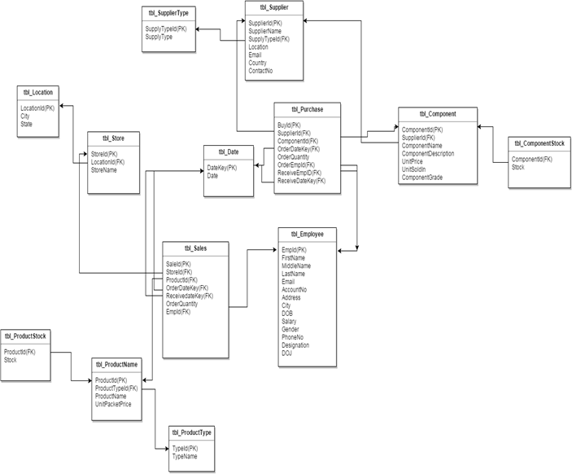

3. FUNCTIONAL REQUIREMENTS:-

3.1 REQUIREMENTS IN SCOPE
The project scope will include:
- Retrieve the data out of unstructured or poorly structured data sources for further data processing using regular expressions, identifying common sections in a domain and using text analytics.
- Convert the set of data values from the data format of the source data system into the data format of the destination data system i.e. Database using many to one and one to many transformations.
- Identify incomplete, incorrect, inaccurate, irrelevant, etc. parts of the data and then replace, modify, or delete this dirty data or coarse data.
- After the data has been cleansed and transformed into a structure consistent with the requirements, data is ready for loading into the data warehouse.
- The data warehouse is used to analyze the data and create various reports based on the business requirements.
- The reports are represented as per the business requirement i.e dashboards, visual displays- chart, list, crosstabs.
- The reports are used to take profitable future decisions and monitoring solutions to control various aspects.

3.2 REQUIREMENTS OUT OF SCOPE
The project scope will not include:
- Data Mining
- Cubes

4. NON FUNCTIONAL REQUIREMENTS

4.1 Security: - It should provide Authentication for valid Users.

4.2 Audit Trail : - A proper Audit Trail should be maintained showing who has accessed a system and what operations he or she has performed during a given period of time.

4.3 Error logging: - Error Log should be maintained

4.4 Multi language Support: - NA

4.5 Performance: - The system should have high response time, throughput benchmark specifications etc. For better performance.

4.6 Scalability: - the Application should be scalable

4.7 Availability / reliability: - It should be available 24*7

Data migration: - NA

4.9Data Retention: - NA

4.10 Legal/ regulatory requirements: - NA

5.HARDWARE AND SOFTWARE REQUIREMENTS

Deployment Environment Requirements
Hardware requirements
Processor/RAM/HDD : 2GB AND Above HDD-20 GB And Above
Web server : NA
Database Server : SQL SERVER 2008 R2
Software requirements
OS for Web server : WINDOWS 7
OS for Database Server : WINDOWS 7
DBMS : SQL SERVER 2008 R2
Third Party S/Ws : INFORMATICA 9.5.1 AND IBM COGNOS 10.1

Development Environment Requirements
IDE : SQL SERVER 2008 R2, INFORMATICA 9.5.1, IBM COGNOS 10.1
Processor/RAM/HDD : 2 GB AND ABOVE

6. Tables Used
Tables or Entities
Name : tbl_ProductStock
Synonym name : NA
Description : It contains the details of all the product
Indexing parameters : ProductId
Clustering parameters : NA
Attributes/Fields :
No. | Field Name | Description | Size | Type | Optional/  Mandatory? | Constraints | Default values
1 | ProductId | ID for each product | 6 | varchar | Mandatory | FK and should start with ‘P’ | NA
2 | Stock | Quantity of the product | 10 | Integer | Optional |  | NA

Foreign Key | ProductId(referring to ProductId in tbl_ProductName table)

Name : tbl_ProductName
Synonym name : NA
Description : It contains the name and price of all the product
Indexing parameters : ProductId
Clustering parameters : NA
Attributes/Fields :
No. | Field Name | Description | Size | Type | Optional/  Mandatory? | Constraints | Default values
1 | ProductId | ID for each product | 5 | varchar | Mandatory | PK and should start with ‘P’ | NA
2 | ProductTypeId | ID for each product type | 6 | Integer | Mandatory | FK | NA
3 | ProductName | Name of Product | 50 | Varchar | Mandatory
4 | UnitPacketPrice | Unit price of product | 6 | Decimal | Mandatory

Primary Key | ProductId
Foreign Key | ProductTypeId(referring to TypeID in tbl_ProductType table)

Name : tbl_ProductType
Synonym name : NA
Description : It contains the ID and name of all the type of product
Indexing parameters : TypeId
Clustering parameters : NA
Attributes/Fields :
No. | Field Name | Description | Size | Type | Optional/  Mandatory? | Constraints | Default values
1 | TypeId | ID for each product type | 6 | Integer | Mandatory | PK | NA
2 | TypeName | Name of product type | 20 | Varchar | Mandatory

Primary Key | TypeId

Name : tbl_Component
Synonym name : NA
Description : It contains the description of all the components
Indexing parameters : ComponentId
Clustering parameters : NA
Attributes/Fields :
No. | Field Name | Description | Size | Type | Optional/  Mandatory? | Constraints | Default values
1 | ComponentId | ID for each component | 5 | Varchar | Mandatory | PK and should start with ‘C’ | NA
2 | SupplierId | ID for each Supplier | 7 | Integer | Optional | FK | NA
3 | ComponentName | Name of the component | 100 | Varchar | Mandatory | Not Null | NA
4 | ComponentDescription | Description of component | 100 | Varchar | Optional
5 | UnitPrice | Price of component | 6 | Integer | Mandatory | Not Null
6 | UnitSoldIn | Metric measure of component | 6 | Integer | Optional
7 | ComponentGrade | Quality of component | 20 | Varchar | Optional

Primary Key | ComponentId
Foreign Key

Name : tbl_ComponentStock
Synonym name : NA
Description : It contains the details of all the product
Indexing parameters : ComponentId
Clustering parameters : NA
Attributes/Fields :
No. | Field Name | Description | Size | Type | Optional/  Mandatory? | Constraints | Default values
1 | ComponentId | ID for each component | 10 | varchar | Mandatory | FK and should start with ‘CT’ | NA
2 | Stock | Quantity of the product | 10 | Integrer | Optional |  | NA

Foreign Key | ComponentId(referring to ComponentId in tbl_Component table),

Name : SupplierType
Synonym name : NA
Description : It contains the details of supplier type
Indexing parameters : SupplierTypeID
Clustering parameters : NA
Attributes/Fields :
No. | Field Name | Description | Size | Type | Optional/  Mandatory? | Constraints | Default values
1 | SupplierTypeId | ID for supplier type | 7 | varchar | Mandatory | PK and should start with ‘STY’ | NA
2 | SupplierType | Name supplier type. | 20 | varchar | Mandatory |  | NA

Primary Key | SupplierTypeId
Foreign Key
Volumes:
Minimum | Maximum | Average
0 | 2 | 2

Volatility:
Inserts | Updates | Deletes | Reads
25 | 0 | 0 | 0

Name : Supplier
Synonym name : NA
Description : It contains the details of all the suppliers.
Indexing parameters : SupplierId
Clustering parameters : NA
Attributes/Fields :
No. | Field Name | Description | Size | Type | Optional/  Mandatory? | Constraints | Default values
1 | SupplierId | ID for each supplier | 6 | varchar | Mandatory | PK and should start with ‘SU’ | NA
2 | SupplierName | Name of the supplier | 50 | varchar | Mandatory |  | NA
3 | SupplierTypeId | Supplier type | 7 | varchar | Mandatory | FK | NA
4 | LocationCity | City of the supplier | 50 | varchar | Optional |  | NA
5 | Email | Mail of the supplier | 20 | varchar | Mandatory |  | NA
6 | Country | Country of the supplier | 15 | varchar | Optional |  | NA

Testing:
Since our project is divided into three modules we will be performing the agile based testing which includes the quality product having distinct and supreme features over traditional waterfall model. And there are four parameters spike, stress, load and regression testing that is performed.

Unit Test Report
- Author : Rajeshwari
- Table Name : tblComponent
- Functionality Tested : Generation of ComponentId, Replacing ComponentID, ComponentName, SupplierID, UnitPrice, UnitSoldIn and ComponentGrade with null values, Modifying ComponentID, UnitPrice and UnitSold fileds.
- Test Execution Procedure : NA
- Test Results Checking Method : Manual Testing
- Test Data : tblComponent

Test Conditions :
Sl. No: | Objective | Expected Result | Test Cycles
Sl. No: | Objective | Expected Result | Cycle 1 | Cycle 2 | Cycle 3
1. | Generate ComponentId | ComponentId starting from 1001 prefixed with ‘C’. Eg.C1001 | Pass | Pass | Pass
2. | Prefix ComponentId with ‘D’ | ComponentId must begin with ‘C’ | Fail | Pass | Pass
3. | Replace ComponentId with NULL | No NULL values in ComponentId field | Fail | Pass | Pass
4. | Replace SupplierId with NULL | NULL values permitted in SupplierId field | Pass | Pass | Pass
5. | Replace ComponentName with NULL | No null values in ComponentName field | Fail | Pass | Pass
6. | Input non-numeric values in UnitPrice field | Only Integer values are accepted | Fail | Pass | Pass
7. | Replace Unit Price values with NULL | No NULL values are permitted in UnitPrice fields | Fail | Pass | Pass
8. | Input non-numeric values in UnitSoldIn field | Only Integer values are accepted | Fail | Pass | Pass
9. | Replace the values in the ComponentGrade field with NULL or ‘NA’ | ComponentGrade values are optional | Pass | Pass | Pass

Unit Test Report
- Author : Rajeshwari
- Table Name : Employee
Functionality Tested : Generation of full name, Checking validity of email, Replacing ‘#’by ‘-‘ in address, Removing spaces in phone no, Replace ‘FEMALE’ by ‘F’ and ‘MALE’ by ‘M’ in gender
- Test Execution Procedure : NA
- Test Results Checking Method : Manual Testing
- Test Data : Employee

Test Conditions :
Sl. No: | Objective | Expected Result | Test Cycles
Sl. No: | Objective | Expected Result | Cycle 1 | Cycle 2 | Cycle 3
1. | Combining data of first name,middle name and last name columns | New target table Employee containing data from first name,middle name and last name columns must be combined and a new column full name is created | Pass | Pass | Pass
2. | Checking validity of emailed | The mail is should be valid by checking ‘@’ in each mail | Pass | Pass | Pass
3. | Replace ‘#’ in address by a ‘-‘ | Replace ‘#’ in address by a ‘-‘ if ‘#’ is present in the data or it should not be tampered | Fail | Pass | Pass
4. | Remove the trailing spaces of the phone no | Remove the trailing spaces of the phone no of each data | Fail | Pass | Pass
5. | Replace ‘FEMALE’ by ‘F’ and ‘MALE’ by ‘M’ | Replace ‘FEMALE’ by ‘F’ and ‘MALE’ by ‘M’ for each data in gender | Pass | Pass | Pass

Unit Test Report
- Author : Rajeshwari
- Table Name : Store
3. Functionality Tested : Generation of StoreId and City according to LocationId , removing rows with null values and cleansing names
- Test Execution Procedure : NA
- Test Results Checking Method : Manual Testing
- Test Data : Store
- Test Conditions :

Sl. No: | Objective | Expected Result | Test Cycles
Sl. No: | Objective | Expected Result | Cycle 1 | Cycle 2 | Cycle 3
1. | Generate StoreId | StoreId starting from 1 appended with ‘S’. Eg. S001 | Pass | Pass | Pass
2. | Add City according to LocationId | LocationId is 2 then City will be Delhi | Fail | Pass | Pass
3. | Removing rows with null values and cleansing name | Remove “null”, NA, spaces and ‘.’. | Pass | Pass | Pass

Unit Test Report
  - Author : Rajeshwari
  - Table Name : Supplier
  - Functionality Tested : Generation of SupplierId automatically with concatanation of S as prefix , Replacing all null values in all columns with appropriate value,Emailid must contain no other than ‘@’ symbol ,Contact Number must contain 10 digits.
  - Test Execution Procedure : NA
  - Test Results Checking Method : Manual Testing
  - Test Data : Supplier

Test Conditions :
Sl. No: |  |  | Objective |  | Expected Result | Test Cycles
 |  |  |  |  | Expected Result | Cycle 1 |  |  | Cycle 2 |  | Cycle 3
1. |  |  | Generate SupplierId |  | SupplierId starting from 1001 appended with ‘SU’. Eg. SU1001 | Pass |  |  | Pass |  | Pass
2. |  |  | Replace null values in SupplierName with ‘NA’ |  | No null values in SupplierName field | Fail |  |  | Pass |  | Pass
 | 3. | Replace null values in EmailId and any other special character other than @ with ‘NA’ |  | No null values OR Special Character other than @ in EmailId field |  |  | Fail | Pass |  | Pass
 | 4. | Replace null values in Country with ‘NA’ |  | No null values in Country field |  |  | Fail | Pass |  | Pass
 | 5. | Add City according to LocationId |  | LocationId is 2 then City will be Delhi |  |  | Fail | Pass |  | Pass
7. Data Extraction Using Informatica:
Now as all the tables created so we need to extract it from the different sources using ETL Tool.
We are using Informatica as an ETL Tool, the sequential steps of ETL (Informatica) is given below.

- We extract the tables from different source path, in this case we are using Flat files to be extracted for transformation.
- After Extracion Transformation need to be applied according to the Business requirement like union, aggegrator, lookup rank and many more .
- Once the Transformation Is applied we have to create the session in workflow managr for the mapping for which we have applied transformation.
- After successfully execution of workflow we can observe our result in Target Database.
- All described steps given as follows ….
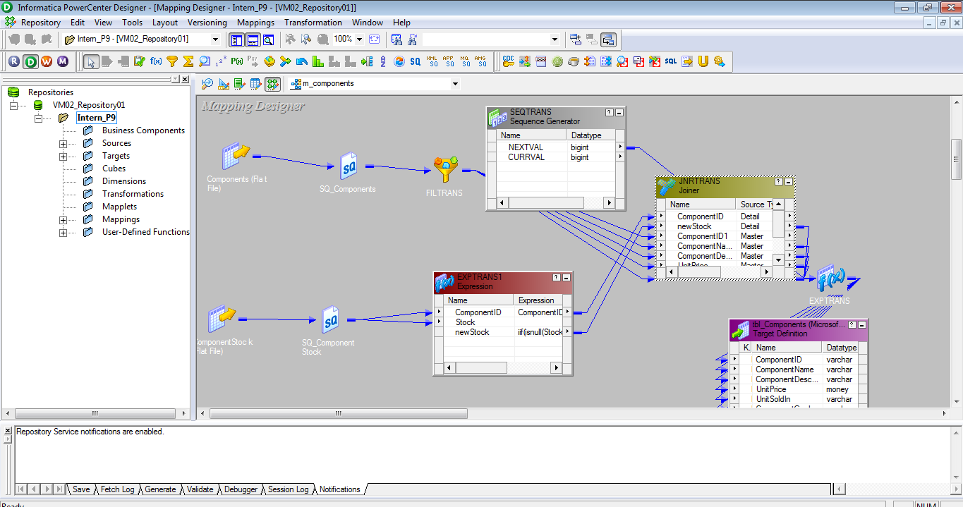
Figure 1.0
In the above diagram first the table component and component stock is extracted in source Analyzer then target table created in Target analyser and Mapping is applied linked with source qualifier.
For this Joiner , expression, sequence generator and filter is used in order to join component id with component .

It is the mapping for the employee table to generate the employee id in roman numbers. For generation of roman number we have used user defined functions.
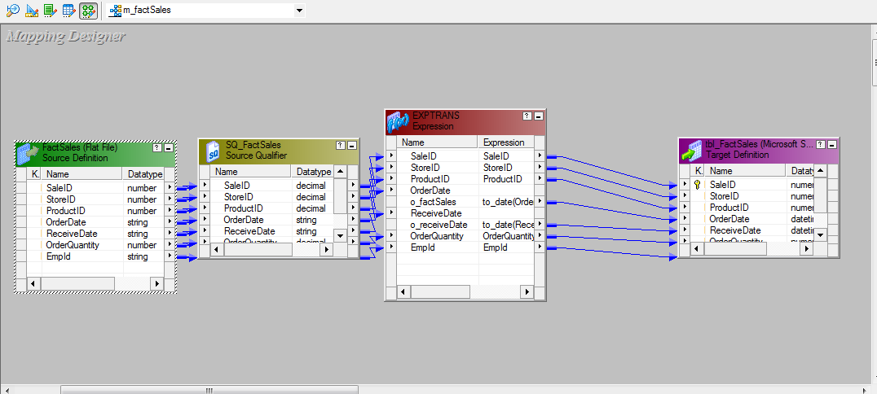
Figure 3.0
This is the mapping for the fact sales table. It stores all the measures of our analytics and we have used expression transformation for the cleansing of the data.
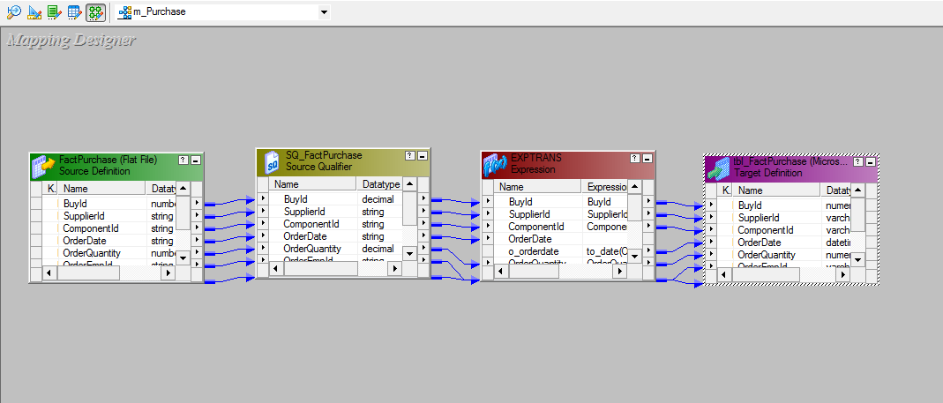
Figure 4.0
This is the mapping for the fact purchase table.
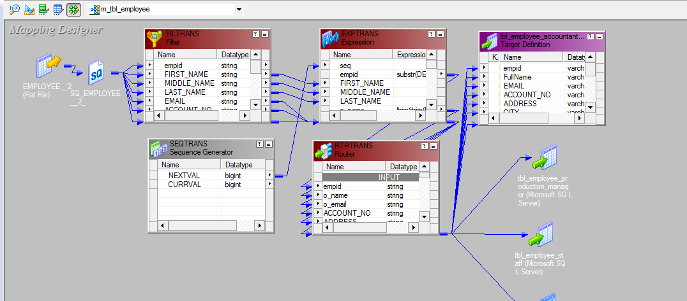
Figure 5.0
The above mapping for the employee table. We have used filter transformation to remove the null values, expression from data cleansing and for business requirements .sequence generator has been used to generate the employee id. Router transformation has been used to route the employee details according to the designation of the employee. Here from single source table we crating four target tables.
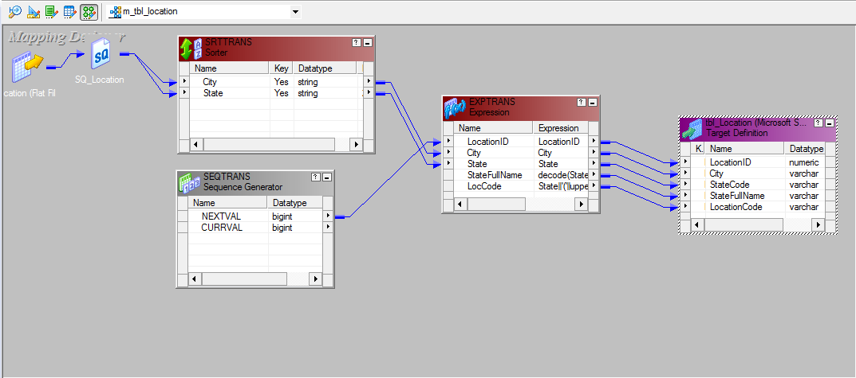Figure 6.0
The above mapping for the location table. We have used sorter transformation for the sorting of the different location in the ascending order. We have used expression table for the generation of location code. 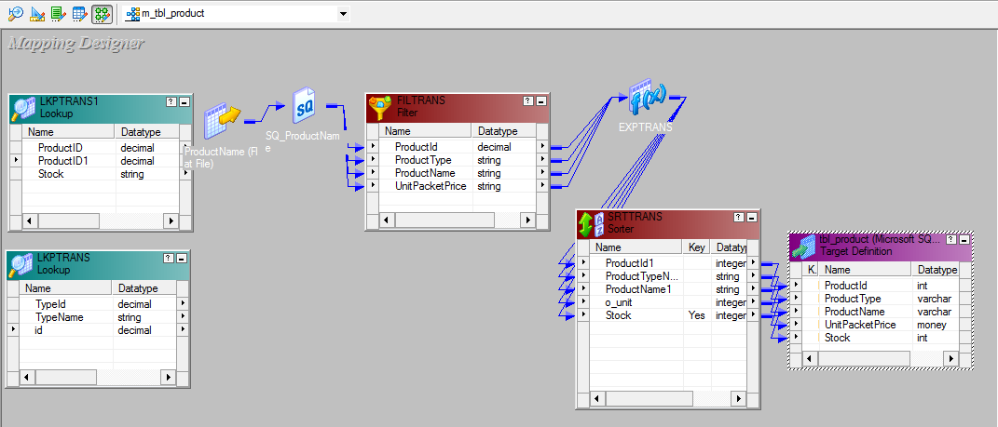Figure 7.0
This is the mapping for the product table. We have fetch the product type name by using an unconnected lookup table between the product table and product type. The return value from the unconnected look up is product type name and joining is based on the product type id.

Similarly we have used another lookup transformation between product table and product stock table. The joining condition is based on the product id and return value is product stock.

We have used filter to remove the null values and sorter to arrange the stock of each product in descending order. 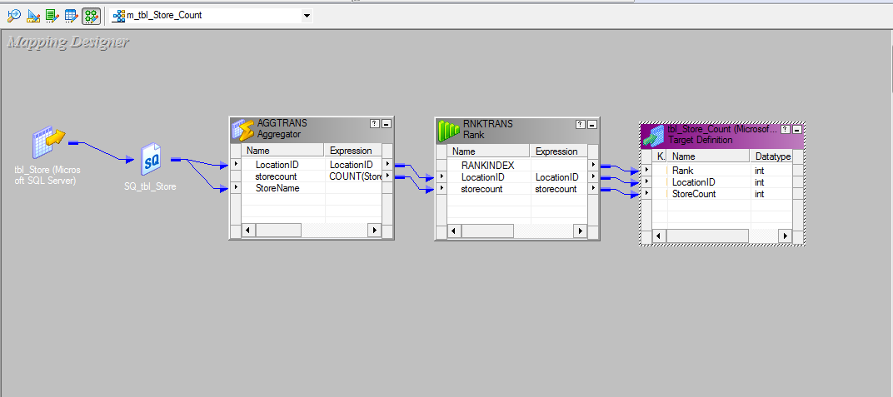Figure 8.0
The above mapping for the count of store in each city. For the counting of the store in each city we have used aggregation and used count for it. We have used rank to view only top five city which has maximum number of stores from the store table.
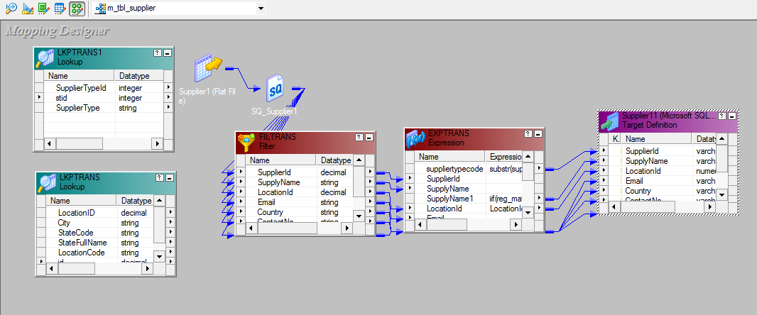Figure 9.0
The above mapping is for the supplier table. We have used two unconnected look up in order to fetch the supply type and location code.
The first lookup is between the supplier table and supply type table, the joining based on the supply id and the return value is supply type.
The look up is used between supplier table and location table. The joining condition is based on the location id and the return type is location code.
Filter transformation is used to filter the null location id. Expression transformation is used to clean the data and to modify it according to the business requirements.
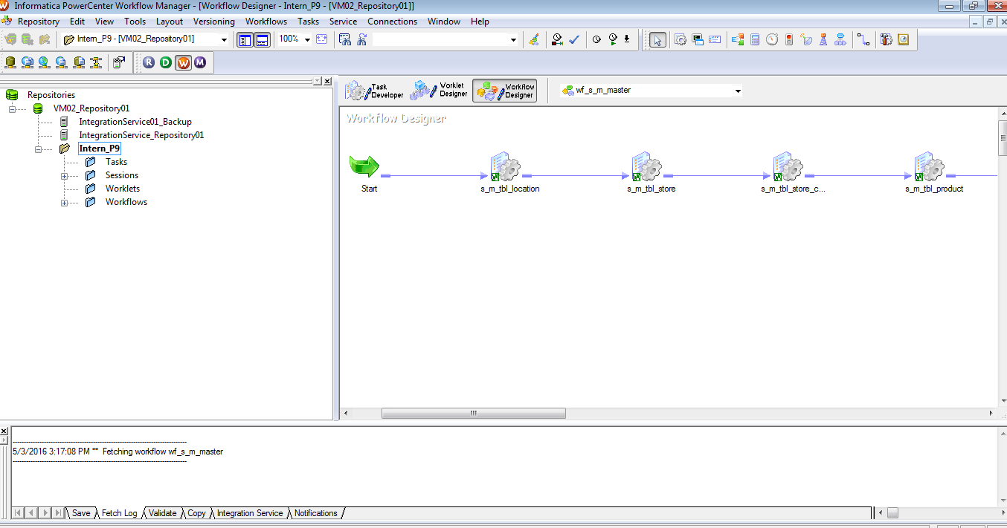
Figure 10.0
The above is a workflow designer where we create task and session for each mapping then execute the workflow. We can view our output table in the SQL studio. 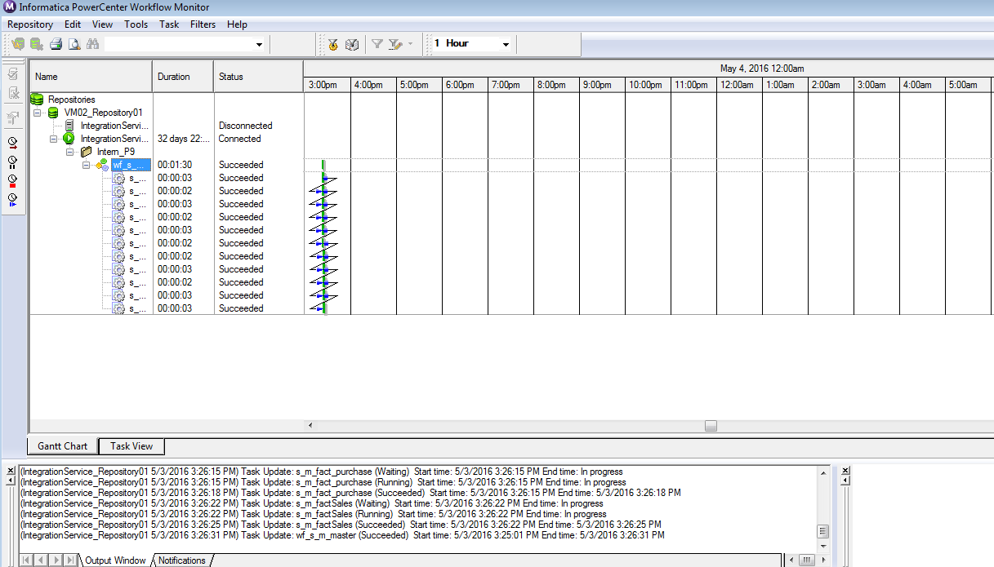
Figure 11.0
The above is the screen shot of the workflow monitor. It monitors the execution of the above session. It shows the status and duration to execute each session.
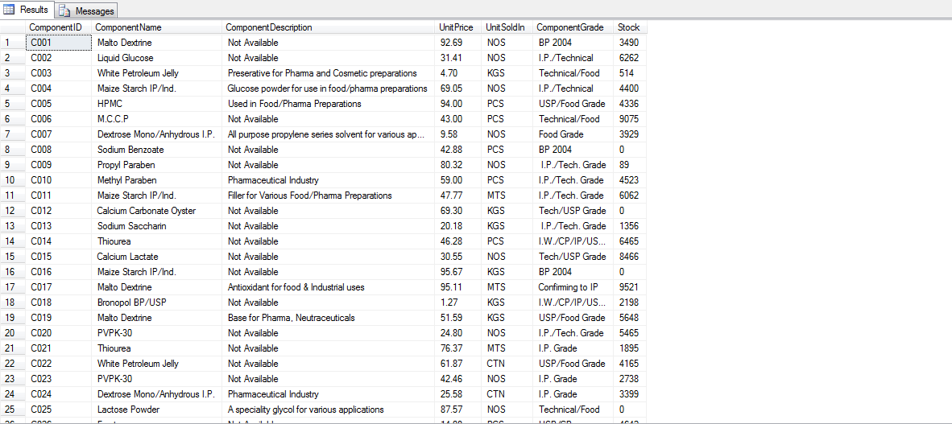
Figure 12.0
The above is the screen shot of the component table. After cleansing and filtering of the data the final output of the target table we can view in SQL studio.

Publishing the Package:
As we have created our Data Warehouse now the next step comes for the package creation.
In order to create package we have to select our created Data Warehouse and choose the desired Attributes (Fact/Dimension Tables) which will help us in Reporting.
- For package creation we are using Framework Manager.
- Create three views Physical , Presentation, AND Business view
- In Physical View we have to remove three Anamolies which includes.
- Self Join
- RolePlaying Dimension
- Loop

- The detailed Fig explaining Physical View :
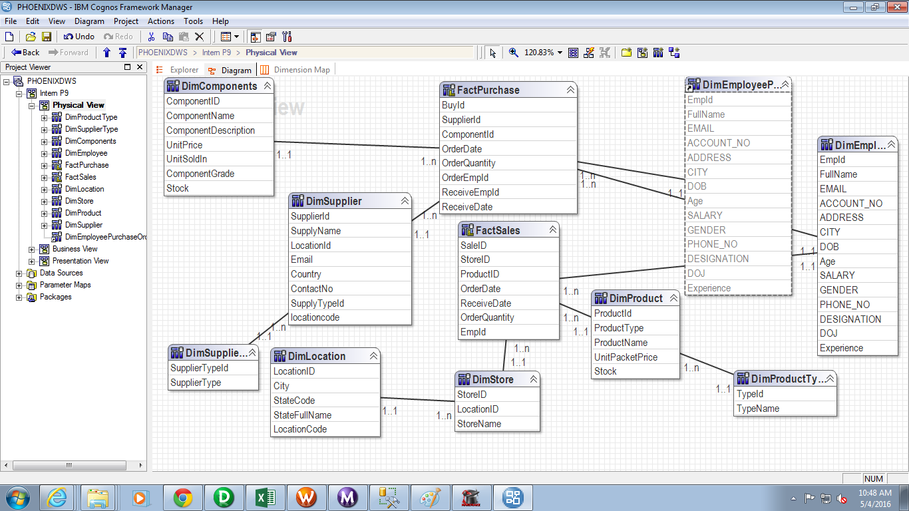
Fig 1.0
- In Business view we have to give the Business Logic to meet the requirement. Like concatenation of FirstName, MiddleName, LastName.
- After Business view we have to create Presntation View where we have to create two seprate folders one for Dimension and another for Fact.
- Fig. below describes Presentation View..
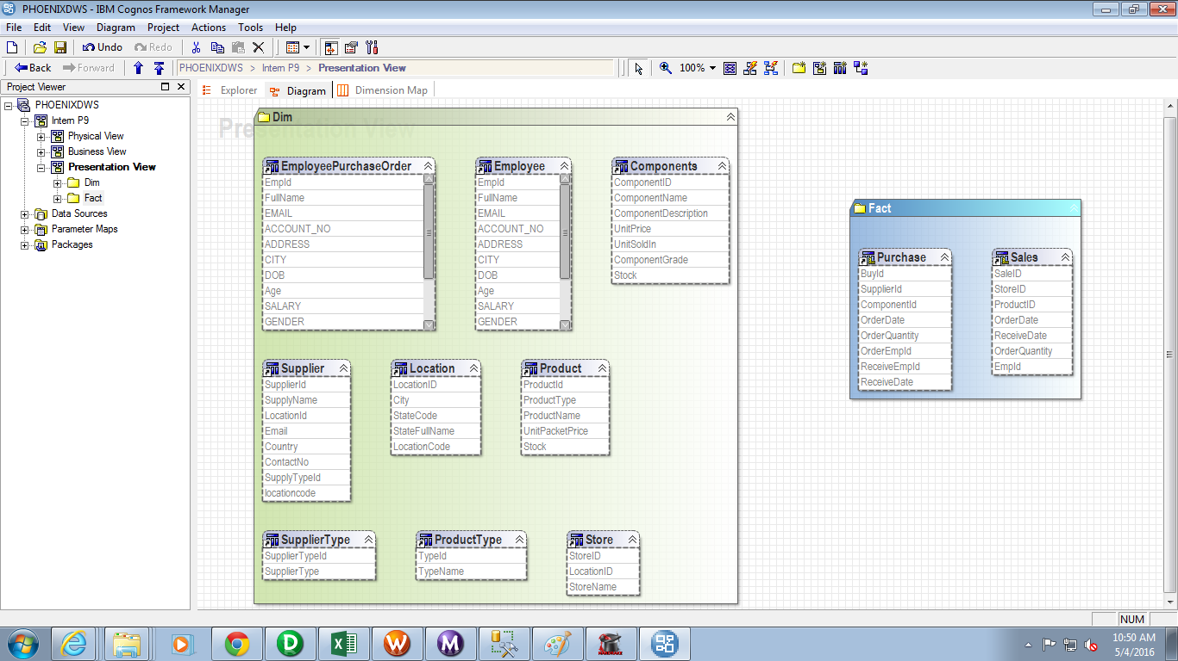
Fig 2.0
- Once The Presentation view is create we have to publish the package.
- After successfully publishing the package we can create Reports based on this Package.

Creating Reports: -

Based on the created Package we have to create a Dashboard so that Phoenix can easily visualize all the Reports and Proper decision can by taken by organisation for the betterment of Firm.
Depending upon the requirement here we are using Pie-Chart, crossTabs, List and Column Charts so that analysis can be done on the observed facts.
Few sample of created Reports are given below …

- Phoneix Dashboard: - The report generated below is the Dashboard /Homepage of the Phoneix by clicking on which all the necessary and required reports can be visually presented to the Phoenix.
Year wise order placed, orderquantity, year wise sales , statewise sales everything can be easily generated by a single click .
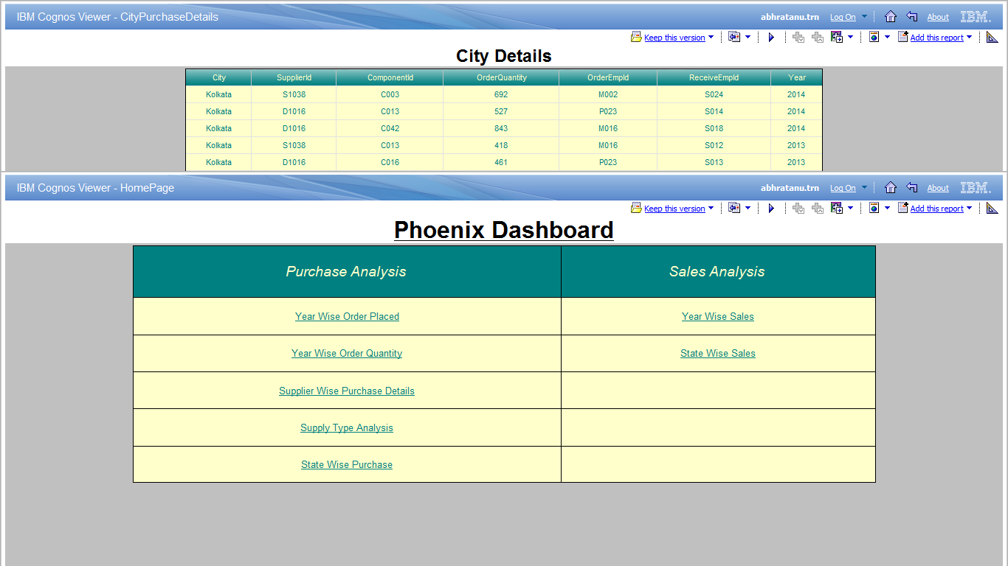

Phoneix Dashboard

- City Wise Purchase Details :-
City wise purchase details can be obtained using charts as well as list but chart give the proper analysis of the city that in which city what were the order quantity.

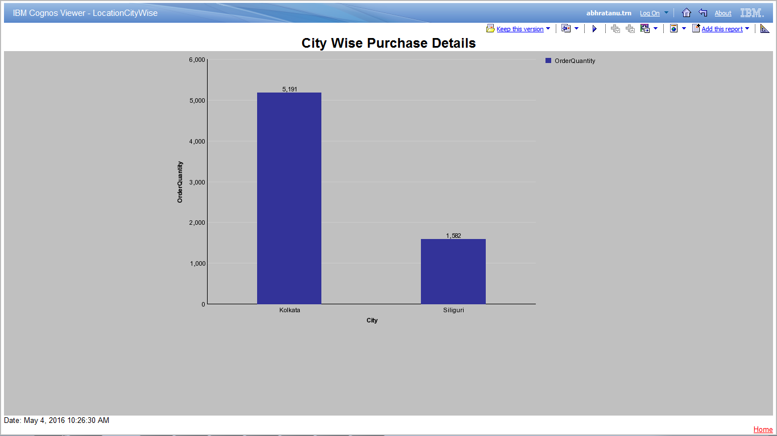
City Wise Purchase Details

3. State Wise Purchase Details:-
State wise purchase details can also be generated to check that in a particular year what total purchase in particular state was. The picture given below describes the state wise purchase details.

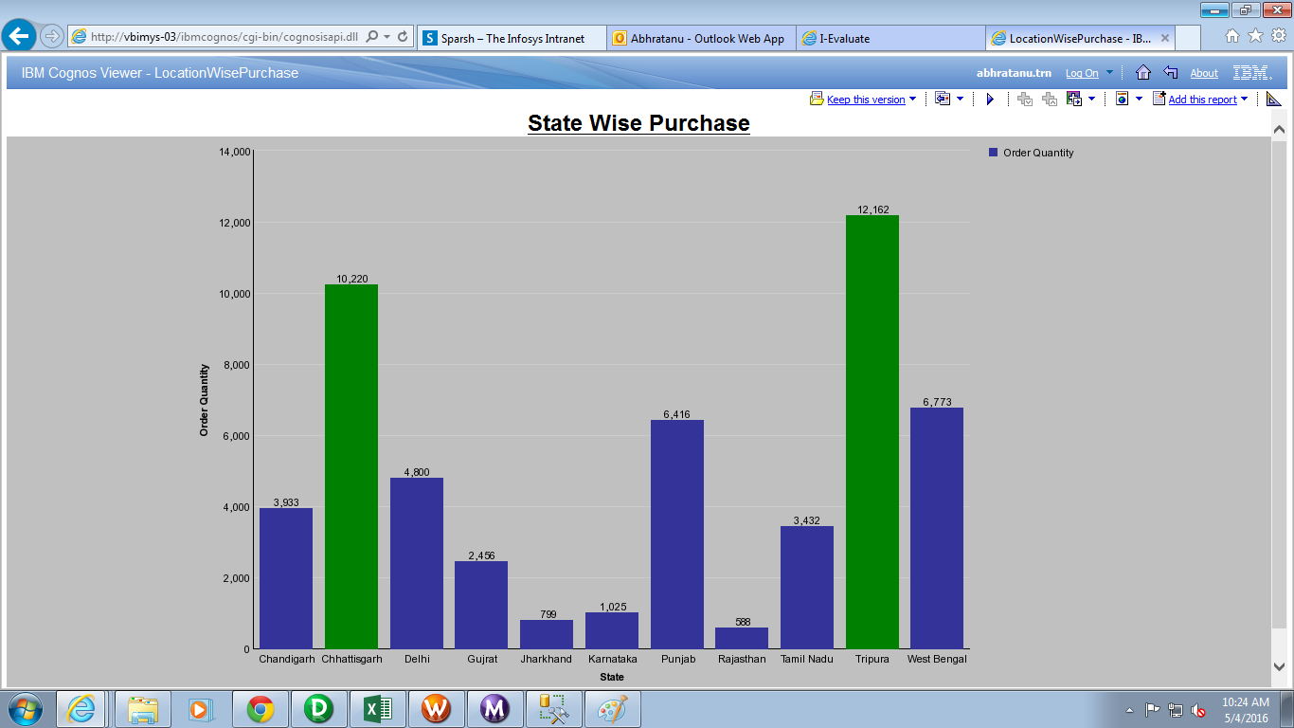

State wise Purchase Details

- State wise details in a tabular format using Crosstab:-
Using tabular view as given below in the fig. we can know the exact data value i.e what amount of data which belons to certain category purchased in particular city in partuclar year.

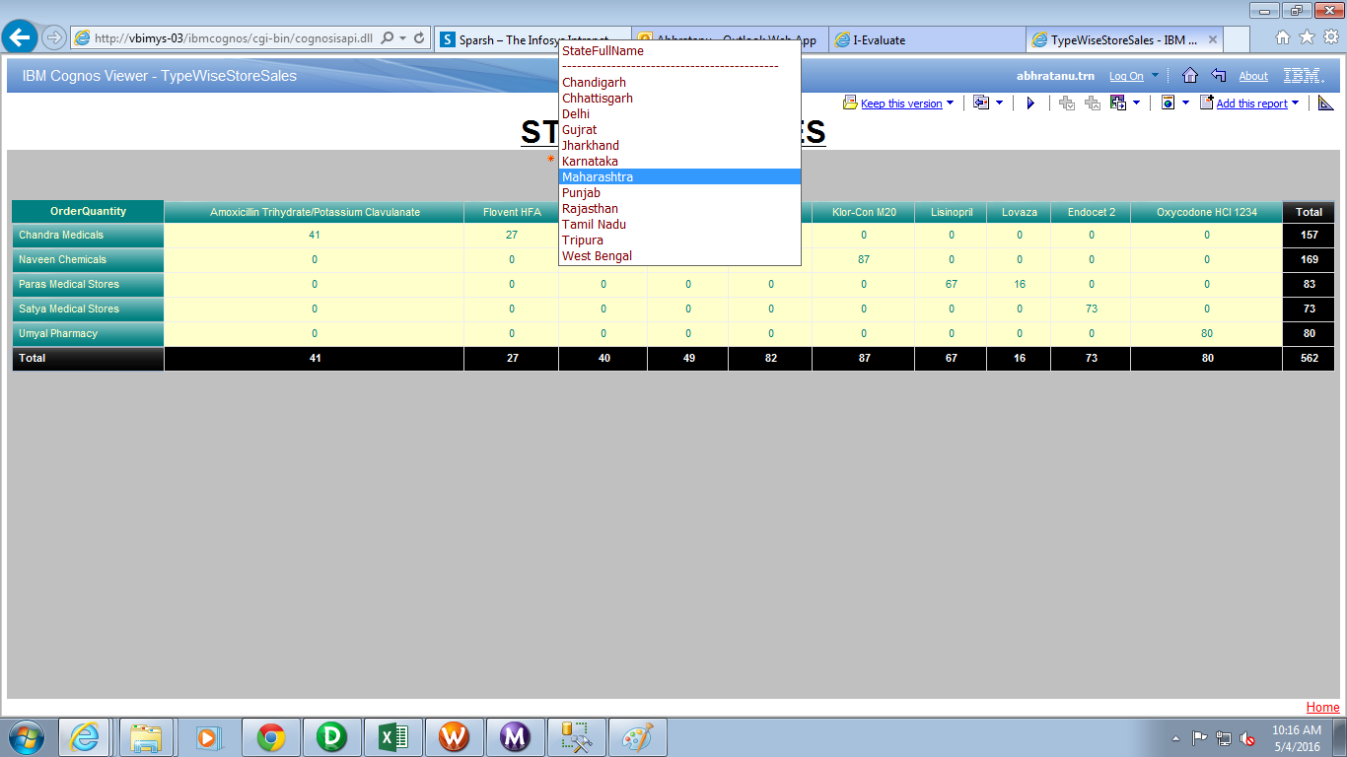

- Supplier Analysis :
Using Crosstabs the below report is generated using which all the details of a particular spare parts can be gathered like how much quantity sold in a Particular year and how much quantity is left in the stock so that a proper analysis can be made for future enhancement of the supplier.

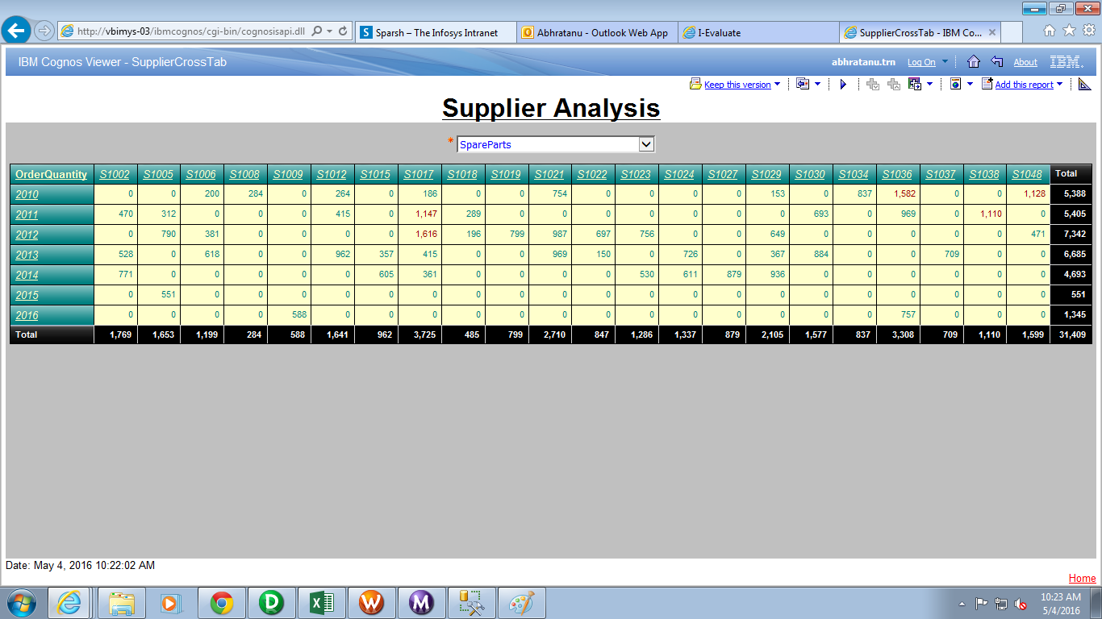
Supplier Analysis

- Suppler wise Purchase Details :
The report given below is screenshot of the supplierwise purchase details like which supplier supplied which category of component in how much amount.
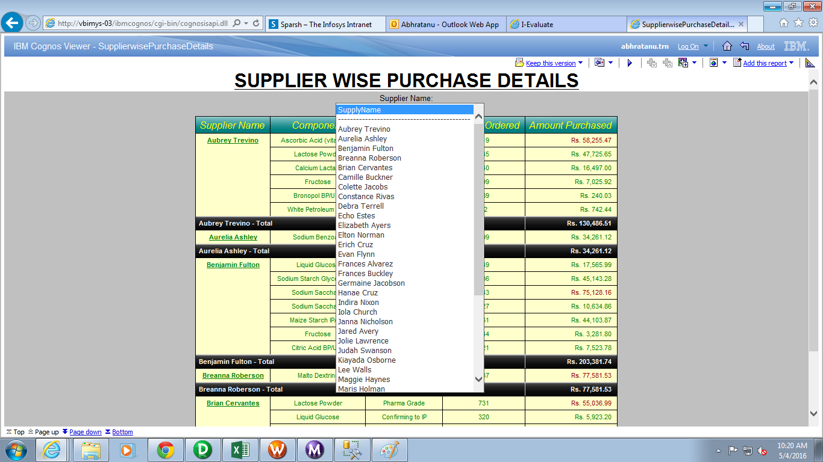
6.2
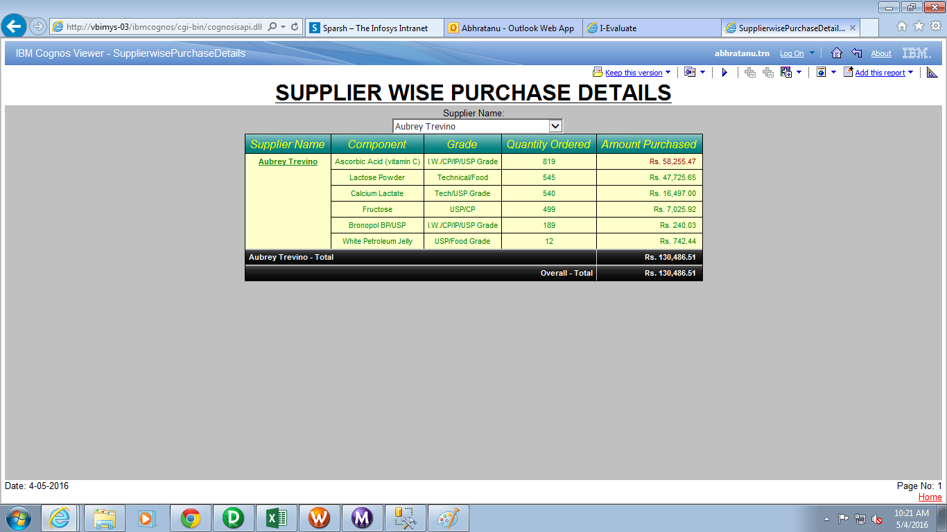
Suppiler wise Purchase Details

- Top Employee Performer :
Phoniex can easily get the top employees who have contributed the most like who sold maximum product in a particular year.

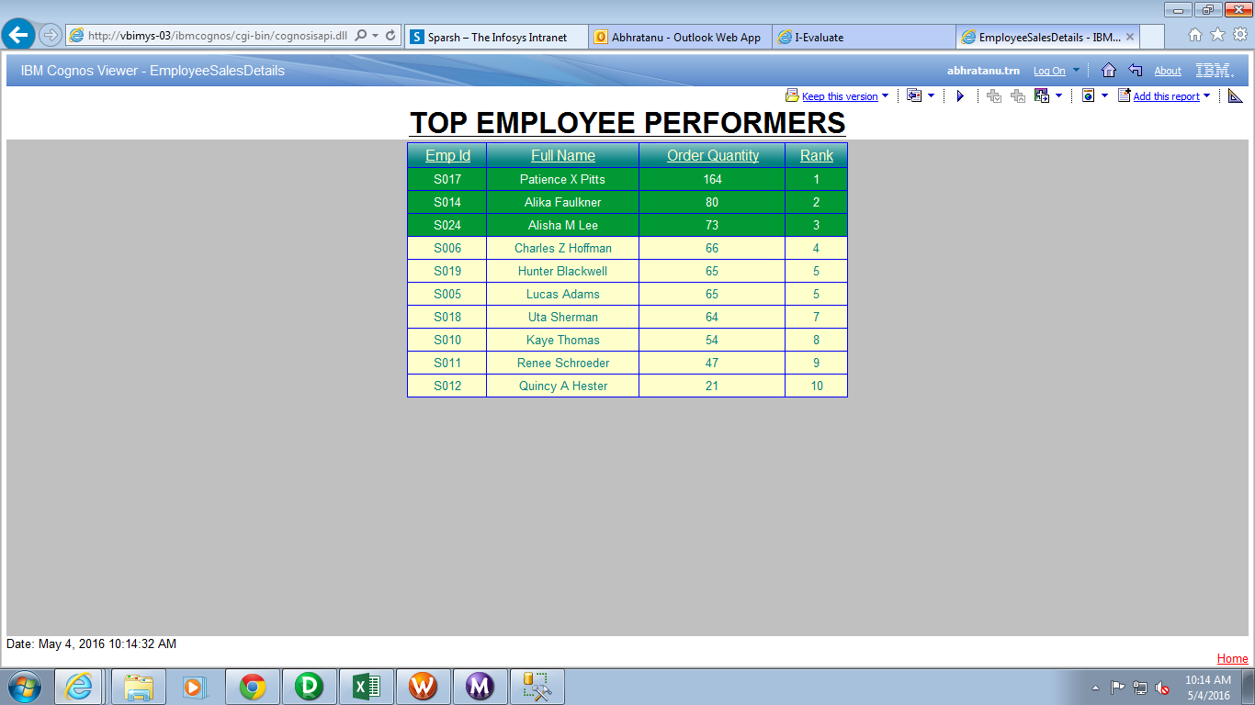

Top employees
- Year Wise Sales :
Using column chart implementation we year wise sales has been generated as given below .

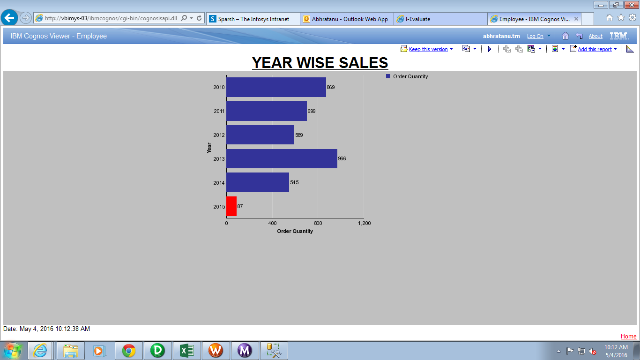

Year wise Sales

Conclusion:

At last we can conclude that we can ease the working of Phoenix Data warehouse by creating a Datawarehouse which contains all the informations rather than using pen/Paper. Working on this project made us aware of the Phoenix which will benefit both the customers as well as company also. It helped us to have a better analysis of data and also helped us to understand which data is important. It made us aware of the various anamolies which are present in data and how to remove these anamolies using ETL tools. For cleansing and transformation we have used Informatica and for a better visual presentation we have used IBM COGNOS.
Working on this project helped us a lot to learn various component of Business Intelligence.

Future Scope of This Project:

The future scope includes applying similar Transformation on large amount of data so that we can handle more anamolies so as to have clean and large Data warehouse. This will make the Phoenix fully automated. Doing so we can generate more reports which will help us for the better understanding of the system. The report will give accurate information of the system and will help extracting meaningfull information from the data.
The effeciancy of the system hence will be improved. It will also help in better data analysis.
The system will become more reliable and fesible.

REFERENCES

www.Datawarehouse.com

APPENDIX
<<Use this section to give any additional information related to this product/project under relevant sub headings>>

